TROON TREKKERS

What is it?

A short, safe, social, fun, and accessible low-level trek. Come and meet new people, make friends, keep active and feel good about yourself.

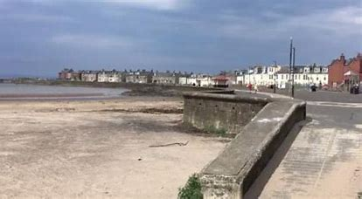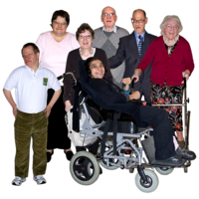

Who is it for?

If you live in Prestwick, Troon, North Ayr, Symington, and surrounding areas, have a learning disability, and would like to spend time with others please come and join us.

Where is it?

South Beach Kiosk, Troon Beach.

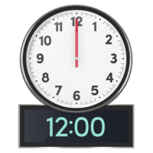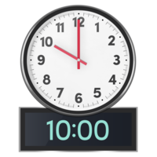When is it?



Every **Tuesday,** starting from 13th June from **10am** to **12pm**.

Don’t forget to dress for the weather!

Does it cost anything?

We will be meeting for cuppa, so bring some money if you would like to join us.

Interested?

Please contact Alice McAllister/Ferguson Grant for more information or to book a space on 01292 614910.

