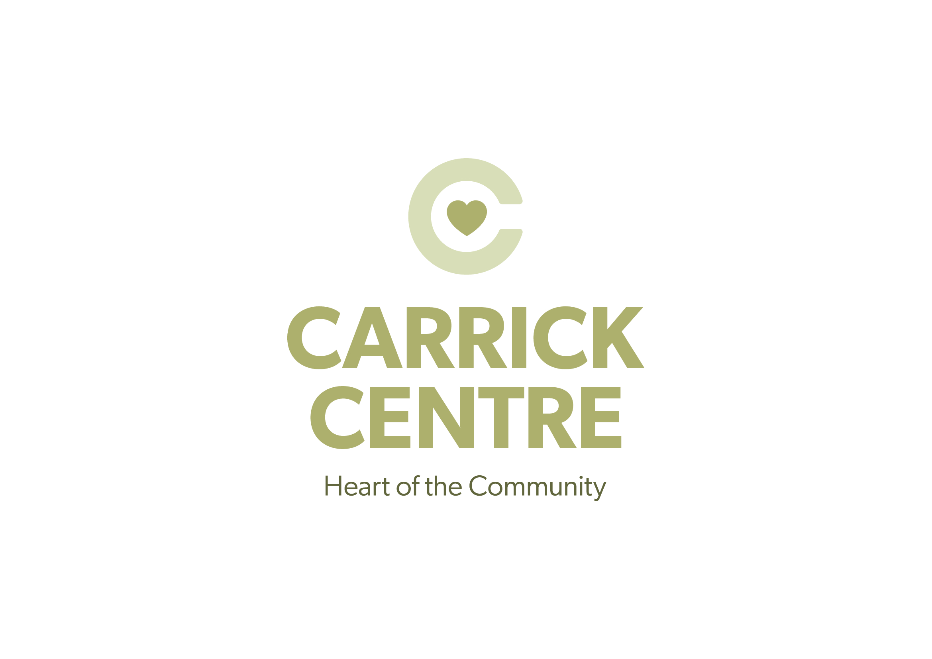
The Carrick Centre
Culzean Road
Maybole
KA19 7DE
Tel: 01655 883222
Email: info@carrickcentre.co.uk
www.carrickcentre.co.uk

Session Worker – Youth Summer Programme

Hours per week: 10

Duties: Work with youth P1-P7 during summer holiday, which will include leisure, sport, recreational and educational activities. Working with Youth Worker to deliver high quality summer experiences for young people.

Qualifications:
- Experience working with young people in formal or informal setting
- Effective communicator
- Flexible
- Able to work evenings.

A current PVG clearance is desirable – Carrick Centre will process PVG application for suitable candidates.

To apply please contact heather.stowe@carrickcentre.co.uk

