**Neurodiversity Newsletter**

**Winter 2024**

# **Welcome**

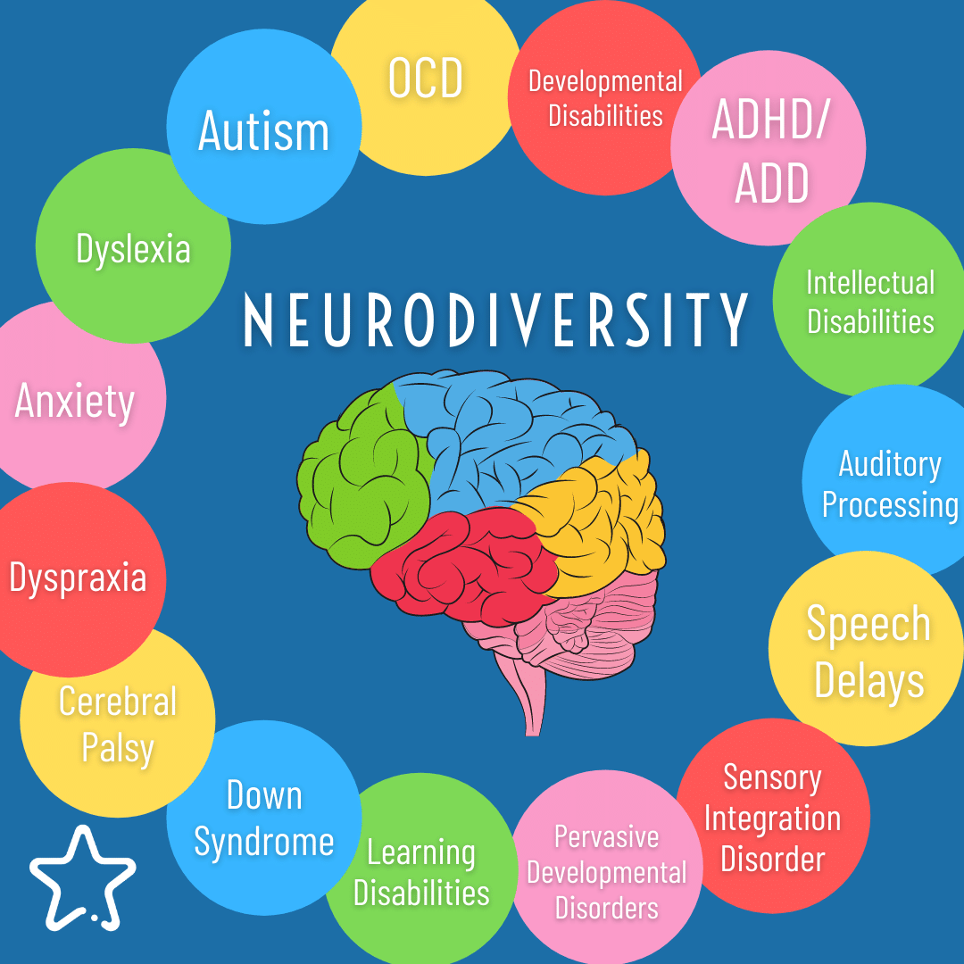Welcome to the first edition and launch of the new South Ayrshire Neurodiversity Newsletter.

South Ayrshire Health and Social Care Partnership are delighted to be able to deliver this newsletter on a quarterly basis. Working in collaboration with local services and charities to provide and share updates and news on the services and supports that are currently available for children, young people and families throughout South Ayrshire. All of these supports and services are accessible to all and require no diagnosis.

We hope that you find this newsletter purposeful and informative. We would be delighted to receive and include any suggestions / feedback from various services.

If you would like to share any service/neuro news and see this featured in upcoming newsletters, please contact Laura Harrop: [**laura.harrop2@aapct.scot.nhs.uk**](mailto:laura.harrop2@aapct.scot.nhs.uk)

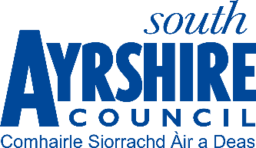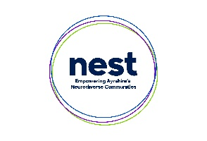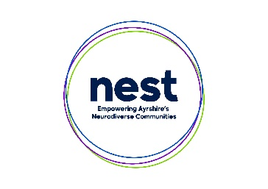

# **Contents**

**Welcome** 1

**Contents** 2

**What’s on in Winter 2024** 2

**Service Information and Referral routes** 10

**Neurodevelopmental Empowerment & Strategy Team (NEST)** 11

**Aberlour, Scotland’s Children’s Charity** 12

**Thriving Communities** 13

**Information & Support** 14

**Neurodiversity News (South Ayrshire)** 15

**Useful Local Contacts** 17



# **What’s on in Winter 2024**

**Youth Work / Youth Activity**

**Education Activity**

**Family/Parent Work**

**Training & Other Information**

**OCTOBER**

**outh work/Activity**

|  |  |  |  |  |  |  |
| --- | --- | --- | --- | --- | --- | --- |
| **Monday** | **Tuesday** | **Wednesday** | **Thursday** | **Friday** | **Saturday** | **Sunday** |
|  | **1st**  **Speech & Language drop-in session**  2 - 4pm  To book call: 07833095374 | **2nd**  **Empower Autism**  4 – 5pm  Ayr Ark | **3rd**  **Empower Autism**  4pm – 5pm  Ayr Ark  **Introduction to Neurodivergence** 10am – 12:30pm Z1 -Youth Bar Girvan  **(PM) Speech & Language**  **Virtual drop-in session**  To book call: 07833095374 | **4th** | **5th**  **ASN Fun & Floats**  4 – 5pm  Troon Leisure Club | **6th** |
| **7th** | **8th**  **Speech & Language drop-in session**  2 - 4pm  To book call: 07833095374 | **9th**  **Empower Autism** 4 – 5pm  Ayr Ark | **10th**  **Empower Autism**  4 – 5pm  Ayr Ark  **(PM) Speech & Language**  **Virtual drop-in session**  To book call: 07833095374 | **11th** | **12th** | **13th** |
| **Monday** | **Tuesday** | **Wednesday** | **Thursday** | **Friday** | **Saturday** | **Sunday** |
| **14th** | **15th**  **Speech & Language drop-in session**  2 - 4pm  To book call: 07833095374 | **16th**  **Empower Autism** 4 – 5pm  Ayr Ark | **17th**  **Empower Autism**  4 – 5pm  Ayr Ark  **(PM) Speech & Language**  **Virtual drop-in session**  To book call: 07833095374 | **18th** | **19th**  **ASN Fun & Floats**  12:30 – 1:30pm  Maybole Leisure Club | **20th** |
| **21st** | **22nd**  **Speech & Language drop-in session**  2 - 4pm  To book call: 07833095374 | **23rd**  **Empower Autism** 4 – 5pm  Ayr Ark | **24th**  **Empower Autism**  4 – 5pm  Ayr Ark  **(PM) Speech & Language**  **Virtual drop-in session**  To book call: 07833095374 | **25th** | **26th** | **27th** |
| **Monday** | **Tuesday** | **Wednesday** | **Thursday** | **Friday** | **Saturday** | **Sunday** |
| **28th**  **Selective Restrictive & Limited Eating**  Venue TBC  Book through Community Paediatrics | **29th**  **Speech & Language drop-in session**  2 - 4pm  To book call: 07833095374 | **30th**  **Empower Autism**  4 – 5pm  Ayr Ark | **31st**  **Empower Autism**  4 – 5pm  Ayr Ark  **Introduction to Autism**  10am – 12:30pm  St Oswald’s Church, Maybole  **(PM) Speech & Language**  **Virtual drop-in session**  To book call: 07833095374 |  |  |  |

**NOVEMBER**

|  |  |  |  |  |  |  |
| --- | --- | --- | --- | --- | --- | --- |
| **Monday** | **Tuesday** | **Wednesday** | **Thursday** | **Friday** | **Saturday** | **Sunday** |
|  |  |  |  | **1st** | **2nd**  **ASN Fun & Floats**  4 – 5pm  Troon Leisure Club | **3rd** |
| **Monday** | **Tuesday** | **Wednesday** | **Thursday** | **Friday** | **Saturday** | **Sunday** |
| **4th** | **5th**  **Speech & Language drop-in session**  2 - 4pm  To book call: 07833095374 | **6th**  **Empower Autism**  4 – 5pm  Ayr Ark | **7th**  **Empower Autism**  4 – 5pm  Ayr Ark  **(PM) Speech & Language**  **Virtual drop-in session**  To book call: 07833095374 | **8th** | **9th** | **10th** |
| **11th** | **12th**  **Speech & Language drop-in session**  2 - 4pm  To book call: 07833095374 | **13th**  **Empower Autism**  4 – 5pm  Ayr Ark | **14th**  **Empower Autism**  4 – 5pm  Ayr Ark  **(PM) Speech & Language**  **Virtual drop-in session**  To book call: 07833095374 | **15th**  **I**[**ntroduction to adhd**](https://www.nest.scot/event-details/introduction-to-adhd-14)  **10:00 – 12:30pm**  **Prestwick north parish church -Contact nest to book** | **16th**  **ASN Fun & Floats**  12:30 – 1:30pm  Maybole Leisure Club | **17th** |
| **Monday** | **Tuesday** | **Wednesday** | **Thursday** | **Friday** | **Saturday** | **Sunday** |
| **18th** | **19th**  **Speech & Language drop-in session**  2 - 4pm  To book call: 07833095374 | **20th**  **Empower Autism**  4 – 5pm  Ayr Ark | **21st**  **Empower Autism**  4 – 5pm  Ayr Ark    **(PM) Speech & Language**  **Virtual drop-in session**  To book call: 07833095374  [**Introduction to Neurodivergence**](https://www.nest.scot/event-details/introduction-to-neurodivergence-15)  **6pm – 8pm**  **Via Microsoft teams Contact NEST to book** | **22nd** | **23rd** | **24th** |
| **25th** | **26th**  **Speech & Language drop-in session**  2 - 4pm  To book call: 07833095374  [**Coping with Christmas: Supporting children with additional support needs**](https://www.nest.scot/event-details/coping-with-christmas-supporting-children-with-additional-support-needs-online-2)  **6pm – 8pm**  **Via Microsoft teams Contact NEST to book** | **27th**  **Empower Autism**  4 – 5pm  Ayr Ark | **28th**  **Empower Autism**  4 – 5pm  Ayr Ark  **(PM) Speech & Language**  **Virtual drop-in session**  To book call: 07833095374 | **29th** | **30th** | **1st** |

**DECEMBER**

|  |  |  |  |  |  |  |
| --- | --- | --- | --- | --- | --- | --- |
| Monday | Tuesday | Wednesday | Thursday | Friday | Saturday | Sunday |
| **2nd**  [**Girls & Autism (Online)**](https://www.nest.scot/event-details/girls-autism-online)  **6pm – 8pm**  **Via Microsoft teams**  **Contact NEST to book** | **3rd**  **Speech & Language drop-in session**  2 - 4pm  To book call: 07833095374 | **4th**  **Empower Autism**  4 – 5pm  Ayr Ark | **5th**  **Empower Autism**  4 – 5pm  Ayr Ark  **(PM) Speech & Language**  **Virtual drop-in session**  To book call: 07833095374 | **6th** | **7th**  **ASN Fun & Floats**  4 – 5pm  Troon Leisure Club | **8th** |
| **9th** | **10th**  **Speech & Language drop-in session**  2 - 4pm  To book call: 07833095374 | **11th**  **Empower Autism**  4 – 5pm  Ayr Ark | **12th**  **Empower Autism**  4 – 5pm  Ayr Ark  **(PM) Speech & Language**  **Virtual drop-in session**  To book call: 07833095374  [**Introduction to Autism**](https://www.nest.scot/event-details/introduction-to-autism-16)  **10:00 – 12:30**  **Tesco Extra Ayr**  **Contact NEST to book** | **13th** | **14th** | **15th** |
| **16th** | **17th**  **Speech & Language drop-in session**  2 - 4pm  To book call: 07833095374 | **18th**  **Empower Autism**  4 – 5pm  Ayr Ark | **19th**  **Empower Autism**  4 – 5pm  Ayr Ark  **(PM) Speech & Language**  **Virtual drop-in session**  To book call: 07833095374 | **20th** | **21st**  **ASN Fun & Floats**  12:30 – 1:30pm  Maybole Leisure Club | **22nd** |
| **23rd** | **24th**  **Speech & Language drop-in session**  2 - 4pm  To book call: 07833095374 | **25th**  **Empower Autism**  4 – 5pm  Ayr Ark | **26th**  **Empower Autism**  4 – 5pm  Ayr Ark  **(PM) Speech & Language**  **Virtual drop-in session**  To book call: 07833095374 | **27th** | **28th** | **29th** |
| **30th** | **31st**  **Speech & Language drop-in session**  2 - 4pm  To book call: 07833095374 |  |  |  |  |  |

# **Service Information and Referral routes**

* **Empower Autism** – FREE for ages 11-18, Ayr Ark, Citadel Quay, South Harbour Street, Ayr, KA7 1JB. Every Thursday 4pm – 5pm contact 01292 264020 or email [**admin@ayrark.co.uk**](mailto:admin@ayrark.co.uk)
* **ASN Fun & Floats** - Additional support needs quiet session for families with no music. £3.00 per session (per person), booking in advance up to 8 days ahead. Troon Leisure Club, Barassie Street, Troon, KA10 6LU. First Saturday of every month. Also available at Maybole Leisure Club, Maybole Community Campus, Kirkoswold Road, Maybole, KA19 8BP on the third Saturday of every month 12:30pm – 1:30pm. Tel 01292 269793 to pre book.
* **Introduction to Neurodivergence** – Learn more about Neurodevelopmental differences such as Autism and ADHD workshop. Thursday 3rd October 2024 10am – 12.30pm – Z1 Youth bar, 154 Dalrymple Street, Girvan KA26 9BQ, bookable via NEST Website.
* **Introduction to Autism** – Workshop to learn more about Autism and communication. Thursday 31st October – St Oswald’s Church, Cargill Road, Maybole KA19 8AF, 10am – 12:30pm, bookable via NEST Website.
* **Selective Restrictive Eating -** Workshop delivered via Community Paediatrics. Venue TBC and contact details will be added shortly.
* **NEST – offer a range of workshops bookable here** [**www.nest.scot/workshops**](http://www.nest.scot/workshops)
* [**Child Disability Payment - mygov.scot**](https://eur01.safelinks.protection.outlook.com/?url=https%3A%2F%2Fwww.mygov.scot%2Fchild-disability-payment&data=05%7C02%7Claura.harrop2%40aapct.scot.nhs.uk%7C6c1301a785e34bdd35c208dcfdb33d0f%7C10efe0bda0304bca809cb5e6745e499a%7C0%7C0%7C638664193460355304%7CUnknown%7CTWFpbGZsb3d8eyJWIjoiMC4wLjAwMDAiLCJQIjoiV2luMzIiLCJBTiI6Ik1haWwiLCJXVCI6Mn0%3D%7C0%7C%7C%7C&sdata=ADR8VD4pvLKehSCI0RyLxhhBDghbOtHykJXxNOYryjA%3D&reserved=0)   - You can apply for Child Disability Payment even if the disabled child does not have a diagnosis.
* [**Adult Disability Payment - mygov.scot**](https://eur01.safelinks.protection.outlook.com/?url=https%3A%2F%2Fwww.mygov.scot%2Fbrowse%2Fbenefits%2Fdisability-benefits%2Fadult-disability-payment&data=05%7C02%7Claura.harrop2%40aapct.scot.nhs.uk%7C6c1301a785e34bdd35c208dcfdb33d0f%7C10efe0bda0304bca809cb5e6745e499a%7C0%7C0%7C638664193460396858%7CUnknown%7CTWFpbGZsb3d8eyJWIjoiMC4wLjAwMDAiLCJQIjoiV2luMzIiLCJBTiI6Ik1haWwiLCJXVCI6Mn0%3D%7C0%7C%7C%7C&sdata=5F4XhyvYrPZl5LB7P49HfTk8CNSz%2FHkgP5E9Rovx%2F%2BI%3D&reserved=0) - You can apply and you do not need to include a diagnosis.

# **Neurodevelopmental Empowerment & Strategy Team (NEST)**

**Our Purpose**

**To empower individuals and their families living with neurodevelopmental differences such as autism, attention deficit hyperactivity disorder (ADHD) and foetal alcohol spectrum disorder (FASD).**

**What we do**

Provide information and advice about neurodevelopmental differences such as Autism, ADHD and FASD.

Provide workshops for people to learn more about living with neurodevelopmental differences such as Autism, ADHD and FASD.

**Who is this service for?**

Our service is for children, young people and adults. It is open to anyone in Ayrshire who wants to contact us about neurodevelopmental differences such as Autism, ADHD or FASD. You do not need a diagnosis to access our service.

**How to get in contact?**

You can read more about what we offer at [**nest.scot | Empowering Ayrshire’s Neurodiverse Communities | Home**](https://www.nest.scot/)

Anyone who would like to find out more about our service, or reach out for support can contact us at [**Contact | nest.scot**](https://www.nest.scot/contact)

If you would like to discuss establishing a referral pathway for your team please do get in touch.

**Workshops**

Our workshops are free to attend and reach individuals, parents/carers and professionals. Sessions include an Introduction to Neurodivergence, Introduction to Autism and Introduction ADHD, along many others delivered by key partners in more focused topics such as sensory processing and autism and girls. You can check out our workshop calendar and book at [**Workshops | nest.scot**](https://www.nest.scot/workshops)

# **Aberlour, Scotland’s Children’s Charity**

**Aberlour, Scotland’s Children’s Charity have been commissioned to deliver the new Neuro Connections Service which will be broken down into 3 parts: Family Connections, School Connections and Community Connections.**

**Family Connections -** We intend to support parents and carers of neurodivergent children and young people by being part of the Test Of Change Screening Group and developing Parent/Carer Support Groups in each locality. These groups will be developed over a 12-18 month period and supported by one member of Aberlour staff on a fortnightly to monthly basis depending on the need. Aberlour will provide a safe space for parents and carers to build positive relationships with each other, share experiences, develop coping strategies, share knowledge and signpost to different services.

**School Connections** - Through the Test Of Change Screening Group, engage with all Pupil Support Coordinators to identify any gaps with a view of enhancing Neuro awareness, to be more Neuro welcoming Neuro Aware and Neuro involving. This will be carried out by two members of staff, following the Test of Change around the localities. We will reach out to families who are identified to offer our Parent/Carer Support Groups and also to signpost children and young people to inclusive youth groups we are aware of by utilising current mapping outcomes.

**Community Connections** - We intend to develop a training programme that we will offer to deliver to youth groups within South Ayrshire to help them become more Neuro welcoming, Neuro awareness and Neuro involving. We will connect with these groups through Thriving Communities, South Ayrshire leisure, South Ayrshire Youth Work Network and by utilising current mapping outcomes that have been completed by NEST. We intend to involve Neuro Divergent children and young people in the development of this program. We intend to have the training program developed and ready for delivery by the end of October. The training will be delivered by two facilitators, and we intend to deliver 1-2 sessions per week.

Support will be delivered by workers trained in relation to understanding neurodivergent needs, trauma, and family wellbeing interventions.

# **Thriving Communities**

**Supported Employment**

Thriving Communities provide enhanced support to clients with disabilities to support them to progress into paid, sustainable employment. Support is tailored to the individuals needs and may include personal development, confidence building, money advice and budgeting. Thriving Communities Supported employment programme is designed to help individuals with disabilities or other barriers to employment. Some key components typically involved in our supported employment programmes are:

1. Assessment: Individuals are assessed to determine their skills, interests, and barriers to employment. This helps in creating a personalized plan that fits their needs.
2. Skill Development: Our groups focus on building soft skills, such as communication, teamwork, and problem-solving, which are critical for success in any job.
3. Employer Engagement: Our Employer Engagement Team work closely with employers to help them understand the benefits of hiring individuals with disabilities and provide training on how to create an inclusive workplace.
4. In work Support: Job Analysis and Vocational Profile are used to ensure that the support the client receives when they enter the job is carefully planned and appropriate. Support is individually tailored and targeted and could include induction, training, regular reviews, and workplace mentoring.  The client’s individual goals and the support they will receive will be agreed and recorded on an Action Plan. In many cases, clients will be job coached on site at the employer’s premises to learn specific tasks and work routines. This 1-to-1 support can be gradually faded as the client grows in confidence and learns the job. Over time, the Thriving Communities Officer will identify natural supports in the workplace to ensure there is on-going support for the client from colleagues and supervisors.

**Contact our Thriving Communities:**

**Tel: 01292 612301  
Email:**[**thrivingcommunitiesadmin@south-ayrshire.gov.uk**](mailto:thrivingcommunitiesadmin@south-ayrshire.gov.uk) **The Wallace Tower  
172-176 High Street  
Ayr  
KA7 1PZ**

Supported employment has been shown to be an effective approach for helping individuals with disabilities achieve greater independence and quality of life through meaningful work.

**Tailored job programme**

To enhance the Supported Employment programme, Thriving Communities we have created a range of tailored, part-time jobs. These jobs have been specifically created for people who are ready to progress into the world of work.  Thriving Communities work with colleagues across the council to create job opportunities specifically designed to suit each individual person's circumstances. The jobs are designed around the skills, interests, and capabilities of the person, who is supported throughout by a dedicated Thriving Communities Officer.

# **Information & Support**

**Neurodevelopmental Difference**

* <https://www.nest.scot/learn-zone>

**_________________________________________________________________________**

**Autism**

* [Online Community (autism.org.uk)](https://www.autism.org.uk/what-we-do/community)
* [The Spectrum magazine (autism.org.uk)](https://www.autism.org.uk/advice-and-guidance/the-spectrum)
* [National Autistic Society (autism.org.uk)](https://www.autism.org.uk/)
* <https://www.autismtoolbox.co.uk/>
* <https://saasypenguin.com/>
* <https://southayrshirelifeline.org/listing/autism-support-ayrshire-online-coffee-club/37/>
* <https://www.mindroom.org/>

**_________________________________________________________________________**

**Additional Support Needs (ASN)**

* <https://www.southayrshirelifeline.org/listing/spotty-zebras/692/>

**_________________________________________________________________________**

**Developmental Language Disorder (DLD)**

* [Aberlour Children's Charity - Stop children suffering | aberlour](https://www.aberlour.org.uk/)
* <https://www.youngminds.org.uk/>
* <http://www.addiss.co.uk/>

**_________________________________________________________________________**

# **Neurodiversity News (South Ayrshire)**

**Active Living Adult volunteer opportunities**

We currently have 2 volunteers working with us in our Citadel Gym, supporting classes and gym sessions. This opportunity helps support individuals to develop skills in team working, communication and self-awareness while giving a taste of the working environment.

**Introduction to the groups that are leading on the Neuro work in South Ayrshire**

**Working Group Introduction**

The Working Group was established to lead and support the development of Neurodiverse work in South Ayrshire after the changes were introduced by the Scottish Government in August 2023. These changes stated that responsibility for the assessment of children with neurodevelopmental concerns, but without a significant mental health condition, would no longer rest with specialist CAMHS Child and Adolescent Mental Health Services but within the partnerships in a local authority area.

The Steering group meets on a fortnightly basis and consists of members from SA HSCP, Social Work, SAC Education, NHS Ayrshire and Arran, Children’s Health, Allied Health Professionals CAMHS and NEST etc.

**Screening Group Introduction**

 Services within South Ayrshire have worked together to establish a screening group who will manage all referrals for support for young people who may have neurodevelopmental differences.  This group is made up of one representative from each key children’s service across health and social care, NEST and education.  This group discuss any additional supports the young person and family may be able to access and make recommendations.  This group focuses on ensuring young people and families have the support they need regardless of any diagnosis.  The aim of the group is to move the focus to ‘Support First’.

 With meetings every fortnight, our Support First service started within the Prestwick and Marr clusters in March of this year.  In June, the group opened the Support First service to schools within the Girvan and Carrick clusters.  Our final phase of schools across Ayr will start in early November 2024.

**Pan Ayrshire News**

**Neurodevelopmental service developments**

Across Ayrshire, how we support children and young people with neurodevelopmental differences (NDD) and their families is changing.

We have been listening to the experiences of parents and carers in accessing NDD supports for their children and are working together across children’s services to explore ways of working which best meet the needs of our children and young people.

Whilst we develop these new models, we are reviewing our process for referrals for neurodevelopmental assessments for conditions such as autism or Attention Deficit Hyperactivity Disorder (ADHD). There is a range of other supports for children and their families where there are specific concerns. This includes support from schools and the Neurodevelopmental Empowerment and Strategy Team (NEST) who have information and resources which may be of support. These can be found at [www.nest.scot](http://www.nest.scot)

We are working intensively to ensure we can appropriately support all children and young people with NDD across all our services and look forward to sharing our plans in due course.

**­­­­­­­­­­­­­­­­­­­­­­­­­­**

**Training News**

NHS Education for Scotland (NES) is an education and training body and a national health board within NHS Scotland. We are responsible for developing and delivering healthcare education and training for the NHS, health and social care sector and other public bodies. We have a Scotland-wide role in undergraduate, postgraduate and continuing professional development.

* [**NHS Education for Scotland | NES**](https://www.nes.scot.nhs.uk/)

­

**Neurodiverse Child & Adolescent Mental Health Services (N-CAMHS)**

N-CAMHS provides specialist clinical support, assessment and diagnosis for children/young people experiencing mental health problems, alongside a neurodevelopmental condition such as Autism Spectrum Disorder (ASD) or Attention Deficit Hyperactivity Disorder.

# **Useful Local Contacts**

|  |  |
| --- | --- |
| **Name** | **Contact** |
| **NEST** | aa.nest@aapct.scot.nhs.uk |
| **Aberlour Child Trust** | 01292 671971 |
| **CAMH’s** | 01294 323425 |
| **South Ayrshire Autistic Society** | saas.ayr@gmail.com |
| **Autism Support Ayrshire** | 07500974323 or email [autismsupportayrshire@nas.org.uk](mailto:autismsupportayrshire@nas.org.uk) |
| **ASN Family Network –**  Principal Teacher Inclusion (Teaching & Learning) | [Fiona.Priestnall@south-ayrshire.gov.uk](mailto:Fiona.Priestnall@south-ayrshire.gov.uk) |
| **Spotty Zebras** | [spottyzebras@outlook.com](mailto:spottyzebras@outlook.com) |
| **Thriving Communities** | 01292 612301 or email [thrivingcommunitiesadmin@south-ayrshire.gov.uk](mailto:thrivingcommunitiesadmin@south-ayrshire.gov.uk) |