Important Scottish Water Information
Address 1
Address 2
Town
Postcode

Date
Taking care of your sewer network in Troon.
Project reference
Capital/542989/GeorgeLeslie

Our delivery partner George Leslie will
be carrying out this work on our behalf.

What we are doing
After successfully completing repairs in Bentinck Drive in October of last year, last month we were alerted to a new defect on Dallas Road which required an emergency response. These new works require us to close a section of Dallas Road all traffic.
When are we doing it
Work has already begun to establish a site on Dallas Rd and works could last approx. 8 weeks.
What happens next

- Your water supply and drainage services from your kitchen and bathroom should not be affected by our work.
- There will be a road closure during the timeline above. This will include some access and parking restrictions with the road closure area. (see overleaf) Please follow all diversion signs put in place.
- During the work you will notice noise from construction equipment as they operate between the hours of 8am – 6pm which will include weekend working. We will try to minimise the noise levels where possible.

We ask for your patience and understanding while we complete this emergency work.

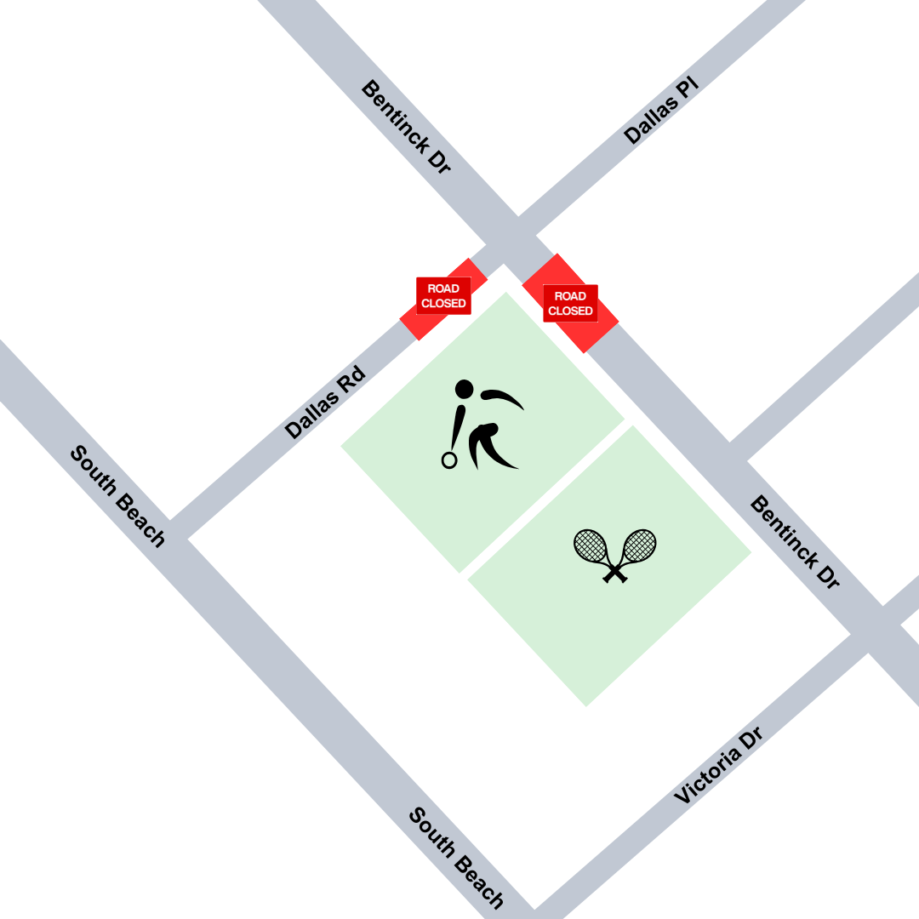

For illustrative purposes only:

